December 2018, UK

PERFECT FOR PLAYTIME!
PetSafe® Brand launches two new pup toys

Dogs can enjoy playtime even more now thanks to the launch of two fun new toys from global pet product expert, PetSafe® Brand. Each of the new toys is designed to redirect bad behaviours like chewing and jumping into positive play, keeping pups busy while also challenging them mentally to keep them actively engaged and alert.
The two toys, which are suitable for all ages and come in a range of sizes are available this month from the PetSafe® Brand website and other selected retailers:

Jewel Pop Treat Holding Dog Toy, from £3.99 – shaped like a sparkling jewel ring, this fun toy holds an irresistible PetSafe® Brand rawhide treat ring that can be replaced again and again. The ring component is made from tough nylon while the jewel is made from sturdy thermoplastic rubber, the same material that makes the soles of running shoes durable. Treats are easy to add; simply unscrew the jewel, slip one rawhide treat ring onto the post and screw the jewel back on for long-lasting engagement with a tasty reward. Available in three sizes, the toy comes with four PetSafe® Brand rawhide treat rings.

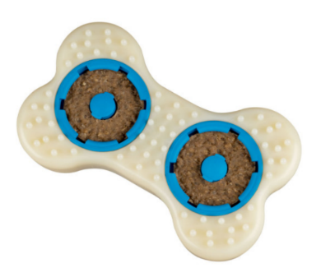
Forever Bone Treat Ring Dog Toy, from £5.99 – available in three sizes, this durable bone-shaped toy is a fun way for even the toughest chewers to entertain themselves! Made from thick nylon and strong vanilla-scented rubber, the toy uses innovative SnapFit™ treat-holding cups to store two delicious all-natural rawhide treat rings to help entice pooches to play longer. The raised nylon nubs and rubber ridges provide a variety of textures to appeal to different types of chewing.

petsafe.com/UK
ENDS

NOTES TO EDITORS
Contact:
For additional information, images and queries, contact Toast PR:
Nicola Ennis - 0870 094 8032 / nicola@toastpr.co.uk

About PetSafe® Brand
PetSafe® Brand is a global pet product expert with wide-ranging innovative products including training, containment, lifestyle and wellbeing product solutions. Visit www.petsafe.com/UK for further details or connect on Facebook, Twitter or Instagram.

