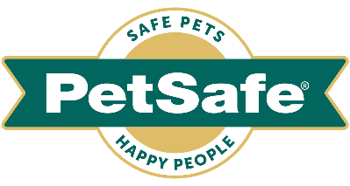

21 April 2022, UK

EXPLORE THE GREAT OUTDOORS WITH YOUR PET THIS SPRING

With the weather warming up, there’s no better time to get outdoors with your pet to enjoy the sunshine and exercise. To help you and your furry friend enjoy the season to its fullest, global pet brand PetSafe® Brand has a range of great products to explore, from toys to travel accessories and pet doors.

The following are available to buy now via www.petsafe.com/UK.
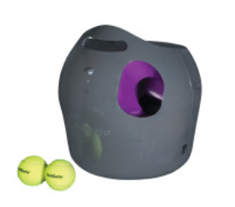
Get set for outdoor play
PetSafe® Automatic Ball Launcher, RRP £152.99 – Why not treat your pup to the ultimate game of fetch for dogs? Suitable for all breeds, this launcher keeps your furry friend entertained while encouraging mental and physical activity. The innovative launcher has nine distance settings and six ball angle settings, plus it has a built-in delay after ball placement, helping instil valuable waiting skills. Battery or mains operated and weighing just 4 kg, the ball launcher can be easily moved around or transported to gardens and parks using its carry handle.

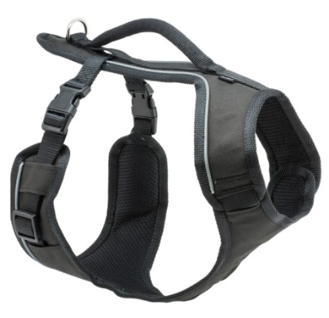
Exercise in comfort
EasySport™ Harness, RRP from £16.99 – this fully adjustable and padded harness provides the ultimate comfort for your furry friend, letting them enjoy life’s adventures in comfort and style. The nylon material and elasticised neckline allow for a cosy fit, while the two quick-snap buckles make the harness easy to get on and off. The top handle provides an extra degree of safety when you need to control your pup quickly.

Road trip fun
PetSafe® has a range of products to make car journeys as safe and comfortable as possible for your pet.
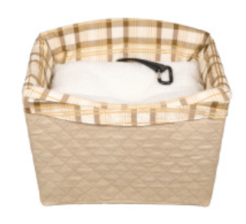
Happy Ride® Quilted Dog Safety Seat, RRP £81.99
This dedicated car seat for smaller dogs makes your car trips safer by connecting securely to your vehicle's seat belts. The included Happy Ride® Seat Belt Tether attaches your dog’s harness to the seat belt and its sturdy, rigid frame is easy to assemble and install in the front or back seat of any car, van or 4X4 with seat belts.

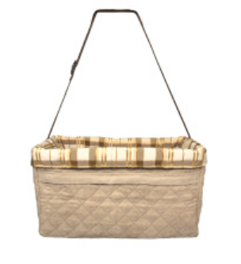
Happy Ride™ Quilted Booster Seat, RRP £45.99 – available in two sizes, this cosy, adjustable booster seat elevates your small pup to the perfect height to see out of the window. The quilted microsuede pairs with a quilted pad liner for an extra-soft, comfy drive and the included safety tether attaches to your dog's harness, keeping roaming pets secure to provide a safer ride for everyone in the vehicle.
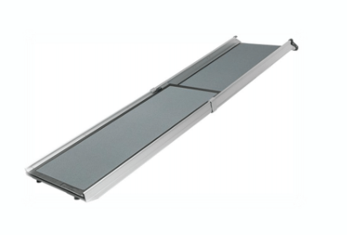
Happy Ride® Telescoping Dog Ramp, RRP £117.99 - this handy ramp helps you give your best friend a leg up to the car when you go on adventures together. It’s perfect if your dog isn’t quite tall enough to hop into the car, or if you want to help protect their joints. Weighing only 6 kg, it’s easy to carry and lift in and out of your vehicle but although it’s light, the durable aluminium ramp can support the largest of four-legged friends up to 181 kg.

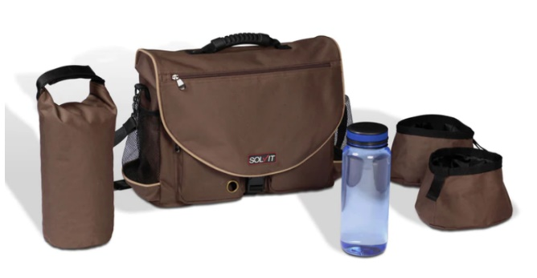
Travel Organiser Kit, RRP £46.99 – this nifty kit can hold all your pet essentials when you go on adventures. Fully loaded, it’s large enough to hold up to one week’s worth of dry food for a medium-size dog, up to a full day's supply of water plus other items such as a lead, food mat, chew toys, medications and first aid supplies.

Pet freedom
PetSafe® Brand has a range of pet doors to help give you and your pet more independence.

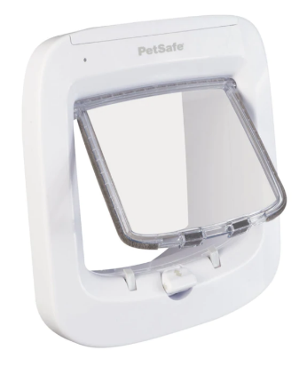
One of its most popular products is the PetSafe® Microchip Cat Flap, RRP £61.99 – this attractive high-tech pet door is simple to install and gives your feline friend the freedom they crave while keeping out unwanted visitors. The cat flap works by reading your cat’s unique microchip ID and doesn’t require an additional collar or accessory. Suitable for pets up to 8 kg, it can be easily programmed for up to 40 microchipped cats, making it ideal those with one or more cats. Featuring a built-in draught excluder, the product is extremely secure, boasting a reinforced dual auto-latch with a four-way manual lock.

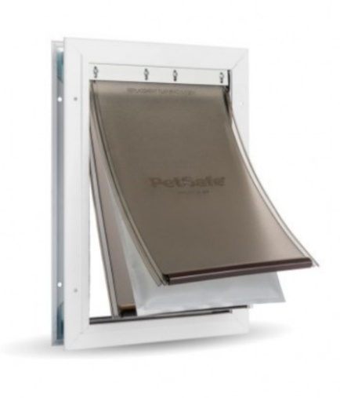
Another door to consider is the PetSafe® Extreme Weather Aluminium Pet Door™, RRP from £81.99 – suitable for pets weighing up to 100 kg, it keeps your home energy-efficient in any climate. Its unique 3-flap system is adjustable and flexible, with a magnetic seal to keep the weather outside and for added protection, the centre flap is fully insulated. To control your furry friend’s outside access and keep stray animals out of their home, you can use the slide-in closing panel. Built to last, the durable metal frame has reinforced aluminium corners and can handle busy households with multiple pets! It is easy to fit into panelled, wood, PVC and metal doors.

petsafe.com/UK
ENDS

NOTES TO EDITORS
Contact:
For additional information, images and queries, contact Toast PR via Nicola Ennis - +44 (0) 870 094 8032 / nicola@toastpr.co.uk or via Rob Steele, PetSafe® Brand (Radio Systems) rsteele@petsafe.net +44 (0) 7850 206534.

About PetSafe® Brand
PetSafe® Brand is a global pet product expert renowned for developing high quality, reliable product solutions that strengthen the bond between pets and pet parents.

Following its launch in 1998, the PetSafe® brand was quickly and solidly built around the provision of trusted training solutions, with innovative ideas in Containment, Training and Bark Control. Whilst these popular categories remain today, other product solutions include Pet Doors, Harnesses and Walking Solutions, Pet Fountains & Feeders, Cat & Dog Toys, Waste Management and a Travel, Access & Mobility range.

Its in-house teams of engineers and innovative design specialists are constantly researching, testing and developing new products, working closely with pet behaviourists, veterinary professionals and every day pet parents to ensure products are effective at keeping pets healthy, safe and happy.

Visit www.petsafe.com/UK for further details or connect on Facebook, Twitter or Instagram.

