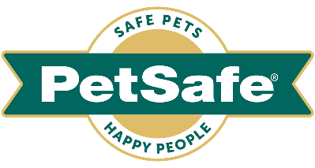
Media information

26 April 2023

Dog owners swear by these eight best buys for happy walkies
From car seats to ramps, harnesses to headcollars and training tools to leads,
don't leave the house without these must-haves this springtime

With spring now officially here – and three bank holiday weekends ahead - dog walkers are getting ready to enjoy better weather, lighter evenings and more regular, longer walks.

Whether they’re a new pet parent or seasoned pro, dog owners are always on the lookout for products that will make walkies more enjoyable and stress-free. As well as their four-legged friends happier and healthier.

Global pet brand PetSafe®, has collated this round-up of its best-selling dog walkies must-haves that shoppers swear by – for young exuberant pups to our older four-legged friends who need a little more help to get out and about in the great outdoors.
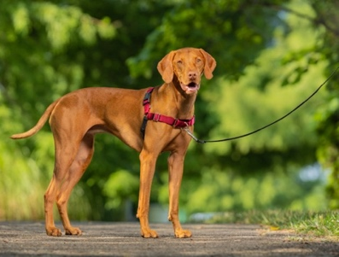
Easy Walk® Harness – RRP from £13.99 to £20.99
Perfect for problematic pullers, this harness is recommended by vets and trainers to gently, quickly and comfortably discourage dogs from pulling on the lead. Its chest strap rests low across his breastbone, so it doesn’t put pressure on his windpipe causing him to cough. Its clever design also features a unique front-chest lead attachment, which prevents a pooch from pulling- by steering to him to the side and redirecting his attention. With convenient quick snap buckles, it’s also easy to put on and remove and comes in a choice of five sizes and three colours – black, red and pink.
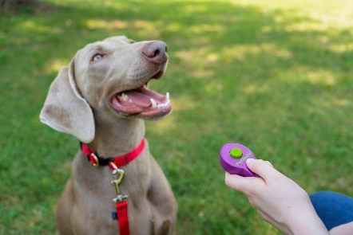
Clik-R™ Training Tool – RRP £5.99
Make training easy and fun whilst out and about on walks with this hand-held Clik-R™ Training Tool. Clicker training is a great way to improve recall and other basic obedience commands - the sound telling him that a treat is coming for his good behaviour. It doesn’t take dogs long to understand how to play this game, and once it clicks – quite literally - they're usually eager for more. For owner comfort, effectiveness and ease of use, it comes with a finger strap and full training instructions.

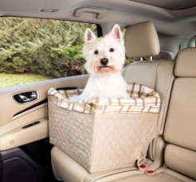
Happy Ride™ Dog Safety Seat – RRP £85.99
Make car journeys safer and more enjoyable for your dearest dog by connecting this seat securely to one of your vehicle’s seat belts. Its sturdy, rigid frame is easy to install in the front or rear seat of any vehicle that has seat belts. With its raised platform, it also makes for a brilliant booster seat, enabling even the most petit of pooches to look out of the window. It’s also a great option to relieve anxiety and motion sickness in the car. For maximum comfort, it features a comfy fleece liner and cushion, which are easy to remove and machine wash. So, he can relax and nap the miles away and you can keep your car seats free from hair, muddy footprints and scratches.

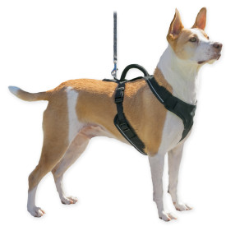
PetSafe® EasySportTM Harness – RRP from £19.99 to £30.99
For the ultimate in comfort and convenience, this EasySport™ Harness is fully padded and adjustable, with an elasticised neckline for the cosiest fit. Its reflective trim adds to its style and safety features and two convenient quick snap buckles make it easy to take on and off. It comes in a choice of three sizes.

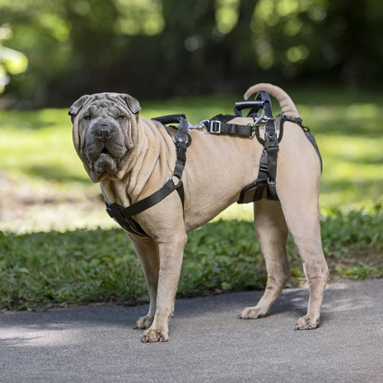
CareLift™ Support Harness – RRP from £46.99 to £48.99
This is the perfect harness to help get your pooch back on his paws. Whether he’s older, recovering from surgery or disabled, the PetSafe® CareLift™ Support Harness provides him with the full body support he needs and is fully adjustable for the best fit. Its clever design also includes a lifting leash at the front and rear handles to gently help ease pressure on his joints – as well as taking the strain off your back. Additional support is provided with the lifting lead extender, or the shoulder strap provided – which are included and depend on the harness size. It features other thoughtful designs to provide comfort for both male and female dogs whilst making toilet breaks. And for ultimate convenience, it’s machine washable and comes in two sizes – medium and large.

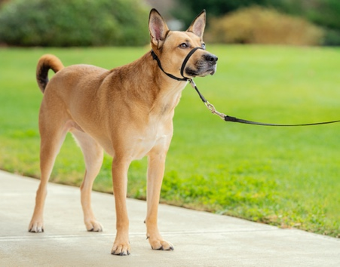
Easy Walk® Headcollar – RRP £24.99
Enjoy immediate, comfortable control on walks and prevent your pooch from pulling, lunging and jumping with this vet-recommended training headcollar. Its adjustable nose loop slips easily over his head and, when he tries to pull, his nose is steered to the side and his body follows. Its soft nylon headcollar sports a ribbon finish and a comfortable felt pad lining and it can be attached to any non-extending lead.

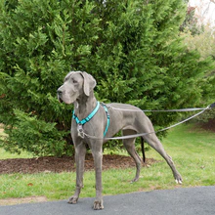
Anti-Pull Dog Lead – RRP £16.99
Another alternative to put a stop to problematic pulling, this versatile double-ended lead attaches to the front and back of the PetSafe® 3 in 1 Harness and Car Restraint. When control can be reduced, it’s quick and easy to convert into a 1.2m lead. For maximum comfort, it has a padded, free-floating handle that self-adjusts to your dog’s movement and it’s made from reflective nylon, for extra visibility in the dark.

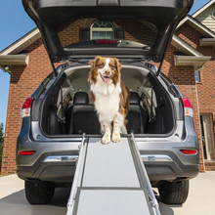
Happy Ride™ Telescoping Dog Ramp – RRP £138.99
Ideal for big dogs, older dogs and those who aren’t quite tall enough – as well as owners keen to protect their pooches’ joints – this strong, durable aluminium telescopic ramp can support even our largest four-legged friends. It weighs just 6kg so is easy to carry and lift in and out of your vehicle and, is adjustable - from 99cm to 183cm - to suit all vehicles. Some superb safety features include an anti-slip surface and side rails and, when travelling, it conveniently slides for storage and is locked with a safety latch.

PetSafe® Brand’s Rob Steele said: “Dog walking is one of life’s great pleasures and, with three bank holiday weekends coming up – as well as nights getting lighter, days longer and temperatures rising - we’re looking forward to getting out and about more, with our four-legged friends. Whatever their age, obedience and physical abilities. There is so much enjoyment to be had during these special spring times and this round up of leads, harnesses, travel accessories and training tools is sure to make them even better.”

For further information visit www.petsafe.com/UK

ENDS

NOTES TO EDITORS
Contact:
For additional information, images and queries, contact Toast PR via Karen Winstanley - +44 (0) 7501 109296 / karen@toastpr.co.uk or via Rob Steele, PetSafe® Brand (Radio Systems) rsteele@petsafe.net +44 (0) 7850 206534.

About PetSafe® Brand
PetSafe® Brand is a global pet product expert renowned for developing high quality, reliable product solutions that strengthen the bond between pets and pet parents.

Following its launch in 1998, the PetSafe® brand was quickly and solidly built around the provision of trusted training solutions, with innovative ideas in Containment, Training and Bark Control. Whilst these popular categories remain today, other product solutions include Pet Doors, Harnesses and Walking Solutions, Pet Fountains & Feeders, Cat & Dog Toys, Waste Management and a Travel, Access & Mobility range.

Its in-house teams of engineers and innovative design specialists are constantly researching, testing and developing new products, working closely with pet behaviourists, veterinary professionals and every day pet parents to ensure products are effective at keeping pets healthy, safe and happy.

Visit www.petsafe.com/UK for further details or connect on Facebook, Twitter or Instagram.

