18th March 2024, UK

Six must-have products that cats, dogs and their owners will love

As a nation that owns a collective 25 million cats and dogs, global pet brand PetSafe® has compiled its list of best buys to unleash joy - making ‘pawrents’ lives easier, and their cats and dogs healthy, happy and entertained.

From app-enabled pet doors to battery-operated ball launchers, these are the must-have pet products to purchase right now.

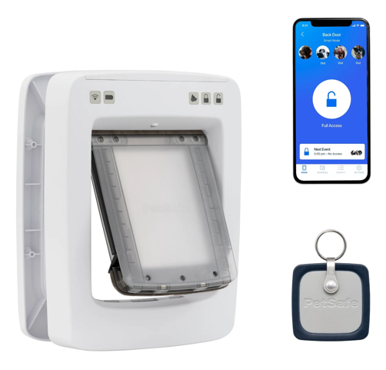
PetSafe® SmartDoor Connected Pet Door – from £439.99 for the medium door (for pets under 11kg) and £539.99 for the large model (for those weighing up to 45kg)
The newest door in the popular PetSafe® portfolio, this app enabled model will help keep cats and dogs happy, healthy and safe when home alone.

It’s the only connected pet door that allows owners to set individual schedules and curfews for each of their pets to maintain their daily routines, using the free-to-download My PetSafe® app.

It’s a brilliant buy for households that own cats and dogs, and great when adding a kitten or puppy to the family. Older pets will still be able to enjoy their outdoor adventures, whilst youngsters will be kept safely indoors until they’re fully vaccinated or old enough to go out unsupervised.

Another USP is that all the smart technology is integrated within the door, which means it operates without a separate WIFI hub for internet connectivity.

Owners will receive notifications to their phone or smartwatch on their pets’ activity, which can also highlight any changes in their behaviour - indicating illness or stress.

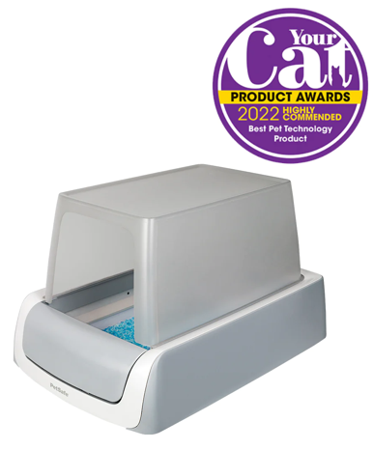
PetSafe ScoopFree™ Covered Self-Cleaning Litter Box, RRP £279.99
Your favourite feline can enjoy premium personal hygiene and health monitoring with the ScoopFree™ Covered Self-Cleaning Litter Box. Not to mention saving owners a job at the same time.

The ingenious design of this litter box includes a health counter that tracks how many times cats have used the box - helping alert owners to possible health issues. It’s also the only self-cleaning litter box that uses disposable premium crystal litter trays to provide hands-off convenience and a clean, fresh smell and automatically rakes cats’ waste into a covered compartment 20 minutes after the box is used. This litter controls odour five times better than the traditional clumping variety and it’s also 99% dust-free for fewer paw prints on the floor.

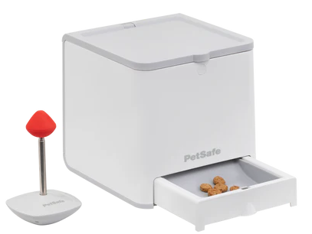
PetSafe® Teach & Treat Remote Reward Trainer – RRP £188.99
This remote-controlled reward-based training tool is designed to teach dogs to develop positive habits by rewarding their good and calm behaviour. It also teaches wider skills - such as agility, obedience, recall and walking to heel – and real results can be enjoyed after just two weeks, when training for ten to 15 minutes each day.

It’s also highly effective when overcoming unwanted behaviours in all ages of dogs - such as whining, barking, pawing and seeking attention – and encouraging calm, even when distracted with household noises.

Reward-based training makes learning fun for dogs and, by treating them when they behave correctly, they’ll want to do so again. Eventually they respond to commands without requiring a reward.

This remote reward trainer comprises a dry food dispenser, training target, and a remote control that can instantly reward a dog’s correct behaviour as it occurs, or immediately afterwards, from up 27 metres away​. It also comes with an array of online product-related training resources and support, including 13 training videos.
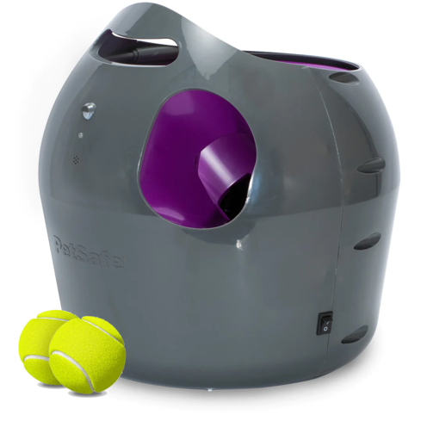
PetSafe® Automatic Ball Launcher - RRP £180.99
The perfect toy for dogs who love balls and to play fetch, this Automatic Ball Launcher can be used for both indoor and outdoor interactive play. With nine distance and six angle settings, the launcher holds up to three tennis balls at a time and shoots them between 2.5 to 9 metres – but only after a tone is played. Its careful design includes built-in motion sensors to safely detect people and pets nearby, and its automatic rest mode ensures our excited dog doesn’t overdo it.

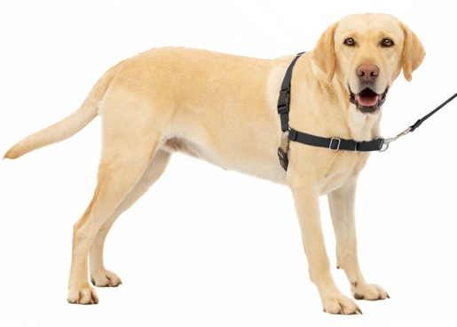
PetSafe® Easy Walk® Harness – from £13.99 to £20.99
Designed to gently discourage dogs from pulling whilst walking on a lead, the harness’ chest strap rests low across his breastbone so as not to cause coughing, gagging or choking. Its clever design also features a unique front-chest lead attachment, which prevents pulling by steering your pooch to the side, whilst redirecting his attention to the owner. Its quick snap buckles make it easy to put on and remove. For maximum comfort and a perfect fit, its design features four adjustment points and is manufactured from a soft nylon material. It’s available in three colourways – black, pink and red – and six sizes, so it’s suitable for almost every breed.

PetSafe® Streamside Ceramic Pet Fountain, RRP £70.99
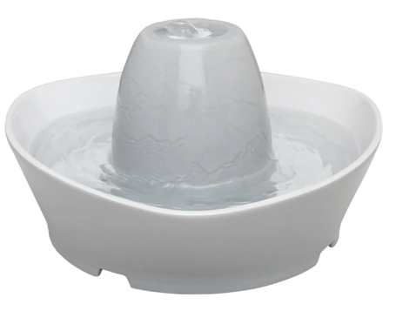
Cats can be very susceptible to dehydration, even more than dogs. This PetSafe® Streamside Ceramic Pet Fountain provides pets with a continuous fresh, filtered stream of water - naturally attracting and encouraging them to drink more.

This popular model holds 1.8 litres of water – making it the perfect size for a cat or small dog – and its whisper-quiet design sees water softly bubble over the hygienic ceramic tower, which makes it perfect for more shy or timid pets. And its pump and carbon and foam filters remove pet hair, saliva and bad tastes from the water, so there’s always refreshingly clean water to drink.

For further information visit http://uk.petsafe.net/

Samples of all products are available for review and a selection of cut out and lifestyle images are available to download here (insert link).

ENDS
NOTES TO EDITORS
Contact:
For additional information, images and queries, contact Toast PR via Karen Winstanley - +44 (0) 7501 109296 / karen@toastpr.co.uk or via Rob Steele, PetSafe® Brand (Radio Systems) rsteele@petsafe.net +44 (0) 7850 206534.

About PetSafe® Brand
PetSafe® Brand is a global pet product expert renowned for developing high quality, reliable product solutions that strengthen the bond between pets and pet parents.

Following its launch in 1998, the PetSafe® brand was quickly and solidly built around the provision of trusted training solutions, with innovative ideas in Containment, Training and Bark Control. Whilst these popular categories remain today, other product solutions include Pet Doors, Harnesses and Walking Solutions, Pet Fountains & Feeders, Cat & Dog Toys, Waste Management and a Travel, Access & Mobility range.

Its in-house teams of engineers and innovative design specialists are constantly researching, testing and developing new products, working closely with pet behaviourists, veterinary professionals and every day pet parents to ensure products are effective at keeping pets healthy, safe and happy.

Visit www.petsafe.com/UK for further details or connect on Facebook, X or Instagram.

