November 2019, UK

PETSAFE® BRAND INTRODUCES NEW DOG & CAT TECH TOYS IN TIME FOR CHRISTMAS

Global pet product expert, PetSafe® Brand today announced it is introducing three new dog and cat toys to its popular Play & Challenge range in time for pet Christmas gifting season. The additions highlight the business’ continued focus on both the category and pet tech and include the first electronic dog toy since the Automatic Ball Launcher, the new Ricochet Electronic Dog Toys.

Every Play & Challenge toy is designed to redirect bad behaviours like chewing and jumping into positive play, keeping pets busy while also challenging them mentally to keep them actively engaged and alert. The toys are suitable for all pet ages and come in a range of sizes.

The following new additions are available to consumers this month from the PetSafe® Brand website and other selected retailers:

For dogs:
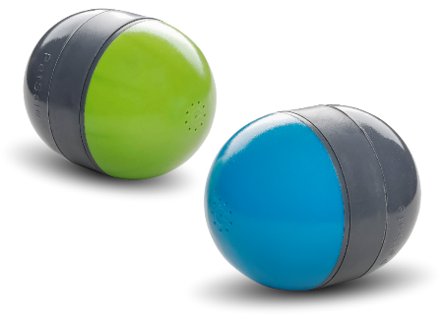
Ricochet Electronic Dog Toys, RRP £34.99 – an innovative addition to the range, these two electronically paired, Bluetooth enabled toys offer an irresistible squeaking sound. As the dog plays with the first toy, the second toy squeaks, with the sound alternating between each toy. The game stimulates dogs’ hunting instinct and continues as long as they play, automatically shutting off after 30 minutes.

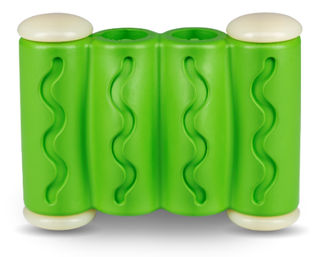
Ribinator Treat-holding Toy, RRP from £6.99 – this treat-holding toy is tough enough to hold up to even the most determined chewers. Each of the toy’s rounded rubber tubes features a Treat Meter™ that can be filled with treats pet owners already have at home such as sticks, dry treats, moist treats and kibble. Treats such as peanut butter and soft cheese can also be spread to the exterior of the toy or owners can decide not to add any treats at all, although they do make the toy even more enjoyable. Available in three sizes, this toy is guaranteed to give dogs hours of fun.

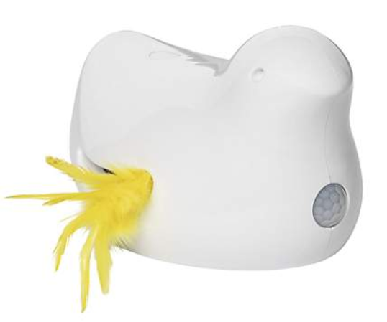
For cats:
From late November 2019: PetSafe™ Peek-a-Bird™ Electronic Cat Toy, RRP, £29.99 – this automated, motion-activated cat toy features an irresistible feather teaser that peeks out and shakes and then disappears. The toy has a Play All Day mode where its motion sensor will awaken the toy if a cat walks by and the toy automatically wakes up every two hours for unexpected fun.

Rob Steele, Marketing Manager, PetSafe® Brand, said: “Play & Challenge continues to be a central focus for our business and we’re constantly looking for ways to innovate to help engage and stimulate pets in new and exciting ways. We’re so pleased to be launching these three new products and are looking forward to hearing the feedback they receive from pet owners.”

petsafe.com/UK
ENDS

NOTES TO EDITORS
Contact:
For additional information, images and queries, contact Toast PR:
Nicola Ennis - 0870 094 8032 / nicola@toastpr.co.uk

About PetSafe® Brand
PetSafe® Brand is a global pet product expert with wide-ranging innovative products including training, containment, lifestyle and wellbeing product solutions. Visit www.petsafe.com/UK for further details or connect on Facebook, Twitter or Instagram.

