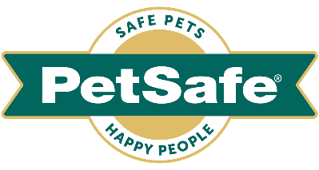

11 April 2022, UK

PETSAFE® BRAND LAUNCHES NEW TRAINING TECH
AT INTERZOO 2022

At Interzoo 2022, global pet product expert, PetSafe® Brand, will be launching an all-new means of training technology – the Audible Bark Collar; a solution to excessive or nuisance barking that uses an innovative audible technology to deter the problem behaviour.

The brand will be showcasing the collar along with a host of products from its broad range of categories, from Waste Management, to Toys, Pet Doors and Travel & Access.

Experts at Hall 6, Stand 140 will be on hand to demonstrate product solutions, talk about the in-depth development and design process, and discuss the brand’s promise of creating high quality, trusted products that help keep pets healthy, safe and happy.

Top training tech

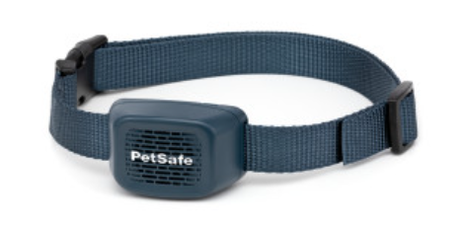
Audible Bark Collar, RRP, £51.99 / 59.99 € – this unique training collar uses sound technology - the newest form of stimulation on the market - to detect and discourage a dog’s excessive barking by immediately releasing a sound to distract them. SoundBurst™ technology offers pet parents a novel and effective alternative that is completely unique from spray, static, vibration, or ultrasonic product solutions. The waterproof and rechargeable collar deters barking safely and consistently, emitting a sound that resembles the spray sound of an aerosol can. At the first bark, a dog will receive a short sound stimulation from the collar, to capture his attention and interrupt the barking. If the barking continues,

the duration of the stimulation will increase gradually through ten levels. As the dog remains quiet, the levels of sound stimulation will gradually decrease with the collar automatically adjusting for dogs by adapting to how frequently they bark.

Electronic play
Pet tech remains a key focus in the PetSafe® Toys category and the business has recently introduced new electronic pet toys for both dogs and cats to the popular range.

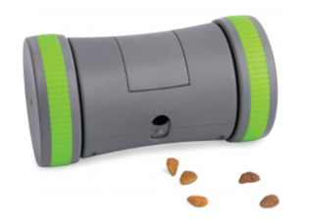
Kibble Chase™ Roaming Treat Dispenser, RRP £32.99 / 35.99 € – this interactive toy dispenses treats as it rolls across the floor in random patterns, enticing dogs and keeping them active and entertained. It is simple for pet parents to use: the battery-powered dispenser just needs to be loaded with kibble, turned on and then they can watch the fun begin. With quiet and durable rubber wheels, the toy has two speed modes suited for hard or carpeted surfaces and its sleep mode lets dogs rest after 10 minutes, with the toy waking up if nudged. The toy holds up to 118 ml of kibble and functions as a great slow feeder for dogs that eat too quickly.

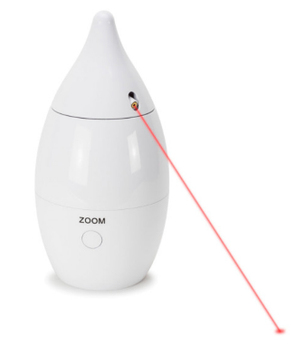
Zoom Automatic Laser Light, RRP £26.99 / 28.99 € – this hands-free toy provides felines with twice the amount of fun with its two darting red dot laser lights that rotate 360 degrees. Cats are instantly attracted to the lights and multiple cats can chase the dynamic patterns the toy creates. As it operates with minimal electronic sounds, even the most timid of cats can enjoy the toy, which features the best laser type for safe playtime. The Zoom also shuts off after 15 minutes to prevent cats from becoming over-stimulated.

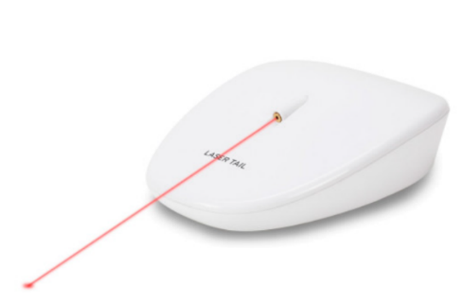
Laser Tail Automatic Laser Light, RRP £20.99 / 22.99 € – this mobile automated laser toy moves around the floor randomly, while its laser light ‘tail’ follows behind and creates patterns that are visually interesting to cats. The toy always moves away from the light to ensure the cats are the ones creating the chase. Like the Zoom toy, it features the best laser type for safe playtime and automatically shuts off (after 10 minutes of play time). It also cleverly navigates out of corners and from underneath furniture.

‘Fun food’ toy play
As well as electronic toys, the PetSafe® Toys portfolio includes a range of other chew and treat dispensing toys. Its recently introduced ‘fun foods’ collection comprises four treat dispensing toys that let pet parents share the fun of cooking with their dogs.

Looking and smelling like snacks, the durable rubber toys help keep dogs’ teeth and gums clean by preventing and removing build-up as they chew on the toys’ textured surfaces. BPA-free, the toys come in a range of sizes and are conveniently top rack dishwasher safe to make cleaning easy.

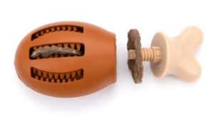
Busy Buddy® Chompin’ Chicken Treat Ring Dog Toy, RRP from £8.99 / 9.99 € – while it is not advisable to give chicken bones to dogs, pets can have hours of safe playtime fun with this chicken-shaped toy. Treats can be added by unscrewing the end and adding on a Busy Buddy® Treat Ring and for extra tastiness pet parents can smear nut butter or dog toothpaste in the outside grooves. To keep dogs entertained for even longer, a Treat Ring can be slid through the grooves of the drumstick and after the rings have gone, the toy’s chicken scent will keep dogs engaged.
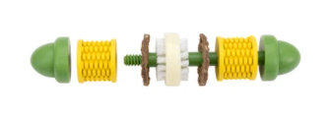
Busy Buddy® Cravin’ Corncob Treat Ring Dog Toy, RRP from £13.99 / 14.99 € – this fun, corn-shaped treat-dispensing toy is butter-scented and the bumps and bristles help keep teeth clean while chewing. Treat rings can be easily added by unscrewing the ends and sliding them on and owners can smear nut butter or dog toothpaste on the corn kernels to extend playtime.

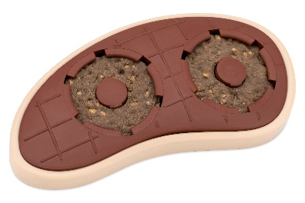
Busy Buddy® Slab O’Sirloin Treat Ring Dog Toy, RRP from £9.99 / 10.99 € – this beef-scented, steak-shaped toy lets owners add up to two treat rings to its refillable SnapFit™ treat-holding cups and owners can smear food or toothpaste into the grooves on the back of the sirloin to keep their dog entertained even longer.

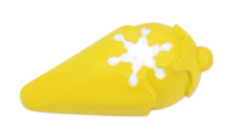
As well as the BBQ products, the new range also includes the Busy Buddy® Frosty Cone Freezer Toy, RRP from £4.99 / 5.99 € – an ice cream shaped rubber treat toy that helps dogs cool down while keeping them entertained. The toy holds dogs’ favourite frozen treats like flavoured water, broth, peanut butter, yoghurt or even wet food for a slow feed option. With its vanilla scent, the toy will keep dogs coming back for more even once the freezable treats have been eaten.

Feline exploration
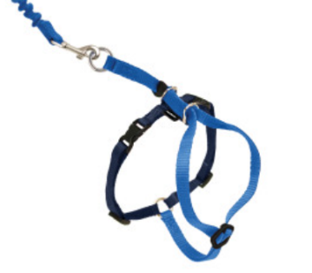
PetSafe® offers a large range of harnesses to help pets – both dogs and cats - enjoy the outdoors in comfort. The newest item in the range is the Easy Walk® Cat Harness, RRP from £9.99 / 10.99 € – this adjustable harness lets owners share enjoyable time outside with their cat, while remaining in comfortable control of their pet. When the cat moves forward, the lead flexes with their movement and gently tightens across the harness shoulder straps, removing pressure from the delicate throat area - preventing harm or escape. Available in three sizes and two colour options.

Core categories in the PetSafe® portfolio

1. Waste Management
PetSafe® has a commitment to developing waste management products that put customers’ convenience front and centre.

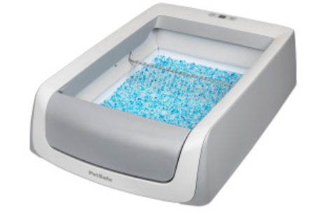
The second generation ScoopFree™ Self-Cleaning Litter Box, RRP £168.99 / 179.99 € is the hero product in the category. The tray’s new features include a sleek neutral grey design that reflects modern home décor trends and a health counter that tracks how many times cats have used the box, helping alert pet parents of possible health issues. Like the ScoopFree™ Original Self-Cleaning Litter Box, the upgraded version is the only self-cleaning litter box that uses disposable litter trays to provide hands-off convenience and a clean, fresh smell. It works by using an automatic rake system that sweeps cats’ waste into a covered compartment 20 minutes after the box is used. The box uses premium crystal litter which provides five times better odour control than traditional clumping litter and being 99% dust-free, it helps keep owners’ floors clean as it doesn’t stick to cats’ paws. Privacy Hood accessory available.

2. Pet Fountains
PetSafe® offers customers a range of pet fountains to help them keep their pets healthy and hydrated, with the free-falling stream of the fountains encouraging and enticing both dogs and cats to drink more water.
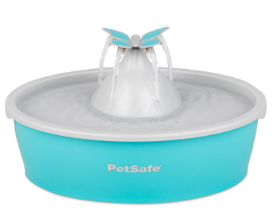
PetSafe® Drinkwell® Butterfly Pet Fountain, RRP £28.99 / 30.99 € – this attractive fountain has a 1.5 litre capacity, making it ideal for cats and small dogs. It continuously circulates and filters pets’ water, encouraging them to drink more, and the water is kept clean with a carbon filter which removes bad tastes and odours, while foam filters catch hair and debris. The fountain has an optional butterfly topper, a fun decorative element that produces four free-falling water streams; alternatively it can be removed to provide a quiet, bubbling flow. The BPA-free plastic fountain is specifically designed with no hard-to-reach crevices to clean, allowing pet parents to spend more quality time with their pet.

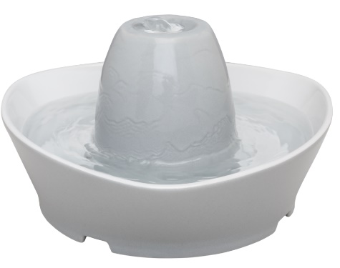
PetSafe® Streamside Ceramic Pet Fountain, RRP £56.99 / 61.99 € – holding up to 1.8 litres of fresh, recirculating water, this stylish, ceramic fountain is perfect for cats and small dogs. Its whisper-quiet flow bubbles over the ceramic tower, making it easily approachable for timid pets. The fountain has a pump and replaceable charcoal and foam filters that work together to remove bad tastes, saliva and hair so pets always have fresh water to drink. With its compact shape, it fits in any home and it is also conveniently dishwasher safe, making it an easy-to-clean and hygienic way for owners to keep their pet hydrated and healthy.

3. Pet Doors
PetSafe® Brand has a range of pet doors to help give pets (and their parents) more independence, while keeping out unwanted visitors.

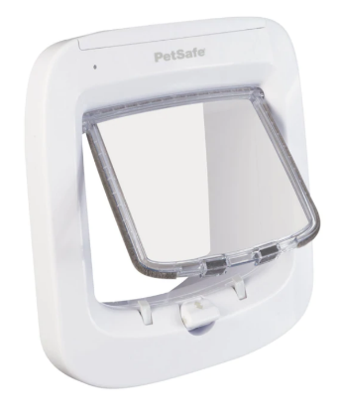
One of its most popular products is the PetSafe® Microchip Cat Flap, RRP £61.99 / 64.99 € – this attractive high-tech pet door is simple to install and gives cats the freedom they crave while keeping out unwanted visitors. The cat flap works by reading a cat’s unique microchip ID and does not require an additional collar or accessory. Suitable for pets up to 8 kg, it can be easily programmed for up to 40 microchipped cats, making it ideal for multi-cat households. Featuring a built-in draught excluder, the product is extremely secure, boasting a reinforced dual auto-latch with a four-way manual lock.

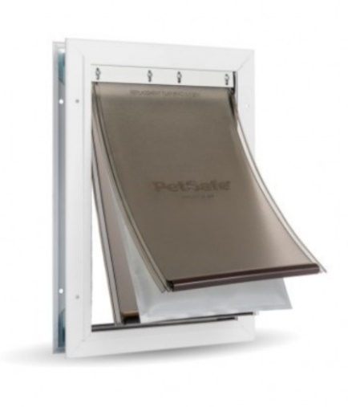
Another door to consider is the PetSafe® Extreme Weather Aluminium Pet Door, RRP from £81.99 / 92.99 € – available in three sizes, the largest being suitable for pets weighing up to 100 kg, it keeps homes energy-efficient in any climate. Its unique 3-flap system is adjustable and flexible, with a magnetic seal to keep the weather outside and for added protection, the centre flap is fully insulated. To manage pets’ outside access and keep stray animals out of owner’s homes, they can use the slide-in closing panel. Built to last, the durable metal frame has reinforced aluminium corners and can handle busy multi-pet households! The door is easy to fit into panelled, wood, PVC and metal doors.

petsafe.com/UK
ENDS

NOTES TO EDITORS
Contact:
For additional information, images and queries, contact Toast PR via Nicola Ennis - +44 (0) 870 094 8032 / nicola@toastpr.co.uk or via Rob Steele, PetSafe® Brand (Radio Systems) rsteele@petsafe.net +44 (0) 7850 206534.

About PetSafe® Brand
PetSafe® Brand is a global pet product expert renowned for developing high quality, reliable product solutions that strengthen the bond between pets and pet parents.

Following its launch in 1998, the PetSafe® brand was quickly and solidly built around the provision of trusted training solutions, with innovative ideas in Containment, Training and Bark Control. Whilst these popular categories remain today, other product solutions include Pet Doors, Harnesses and Walking Solutions, Pet Fountains & Feeders, Cat & Dog Toys, Waste Management and a Travel, Access & Mobility range.

Its in-house teams of engineers and innovative design specialists are constantly researching, testing and developing new products, working closely with pet behaviourists, veterinary professionals and every day pet parents to ensure products are effective at keeping pets healthy, safe and happy.

Visit www.petsafe.com/UK for further details or connect on Facebook, Twitter or Instagram.

