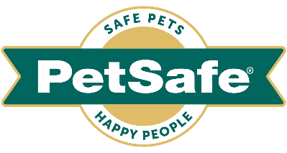

5th August 2022

What your cat’s sleeping position really means
Pet expert analyses nine of the most popular cats sleep positions and reveals the meaning behind each of them – just in time for International Cat Day

The favourite pastime for the majority of the UK’s 12million cats is sleeping. And so, it should be. A healthy adult cat spends an average of 16 hours a day snoozing, whilst kittens, senior cats and those with health problems may need even more rest. One of the main reasons is to conserve energy, as well as regulating body temperature and, quite simply, because they just love to rest.

Their long periods of sleep - and unusual locations and poses – often make us wonder if there is any real meaning to them. And, as it turns out, there is.

Here, to mark International Cat Day, on Monday 8th August, experts at global pet company PetSafe® Brand reveal the true meanings behind some of our cats most common sleeping stances, so that owners can get an even better understanding of what they’re thinking and feeling.

The Lap Curl
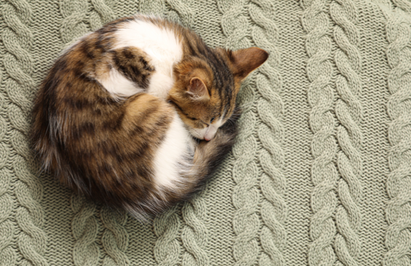
This sleep position - also known as the crescent - is one of the most popular amongst cats. That’s because it helps her to maximize her body heat for added warmth.

It also helps her feel protected – as well as protecting her vital organs - and she may sleep like this it when feeling insecure or wanting to keep snuggly.

The Superman
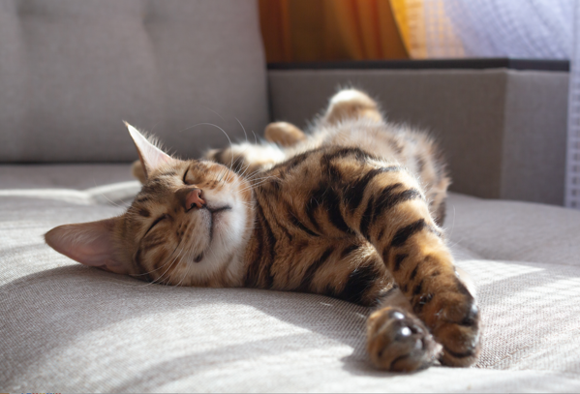
In this rather heroic pose, your cat lies on her stomach and stretches out her paws to the front and the back - just like Superman in flight.

This sleep position is a sign of an extremely relaxed, very content cat who’s very comfortable in her environment. She’s also likely to be in a deep sleep when in this pose.

The Tight Space Squeezer
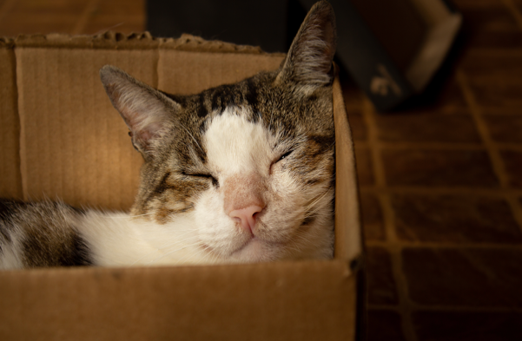
Shoeboxes, bathroom sinks, and empty cardboard boxes are just a few of the weird and wonderful small spaces where your cat might choose to nap because of the protection they offer.
Cats like to squeeze into spaces to sleep as it helps them feel safe and more secure – rather than being exposed to the potential dangers of a wide-open space. But don’t fret, perceived dangers at home can be as trivial as the washing machine or vacuum cleaner.
The Tum Cat
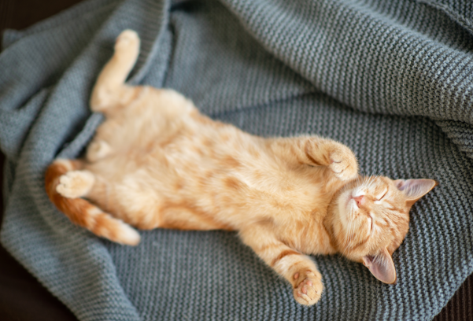
When your cat sleeps belly up, it’s a sign that the two of you have a wonderfully strong relationship.

This is quite a vulnerable position for your cat, so she would only take it when asleep if she’s completely trusting of her home and the people within it.

The Side Sleeper
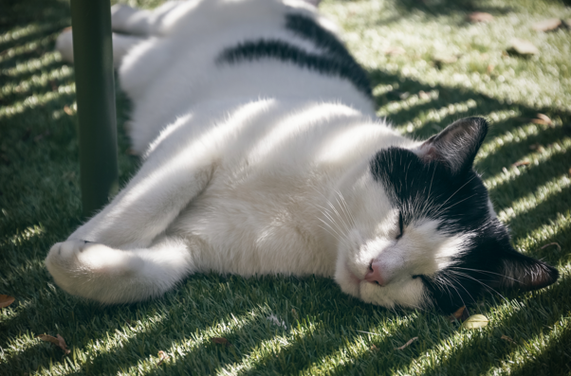
Similar to the Tum Cat’s belly-up position, this popular pose sees your cat expose the most vulnerable area on her body – her stomach. It’s another positive sign that your cat feels comfortable around you, and in her home. Cats who favour this position are often relaxed and feel confident.

This is often a sign of deep sleep, which is likely to see her rest for a longer than when in other positions.

The Co-Sleeper
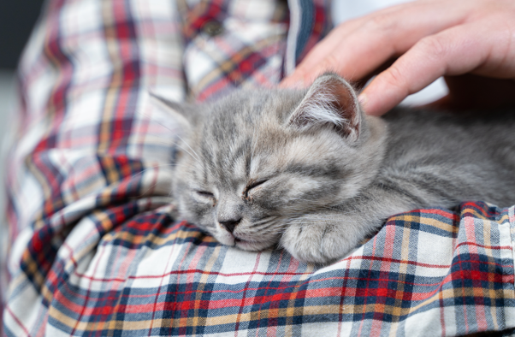
Unlike humans, cats’ natural instincts make them always ready to attack prey or defend themselves. So, since they’re always ready for action, it’s obvious why they want to enjoy extra protection – by feeling even more safe and warm cuddling up on their ‘pawrents’.
This is another heart-warming sign that you have a very strong bond with your cat, and she wants to be close to you.
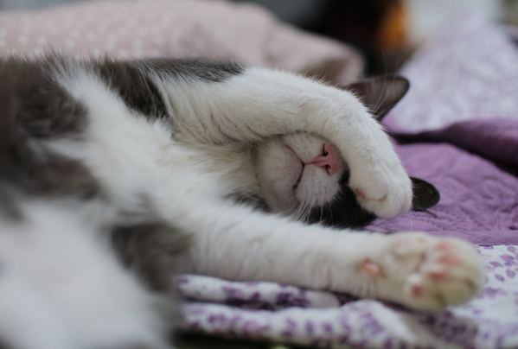
The Face Coverer
There are a number of reasons why your cat covers her face or head with her paws when she’s asleep – from blocking out the sun or bright light, to trying to keep her nose warm. By burying her head, she feels safe, so it could also be a subconscious natural instinct for protection.

Whatever the reason, if her head is covered, chances are she doesn’t want to be disturbed. When in this position, cats can fall into a really deep sleep. It’s a signal to owners that she wants some alone time to rest - a bit like a cat version of a do not disturb sign!

The Loaf
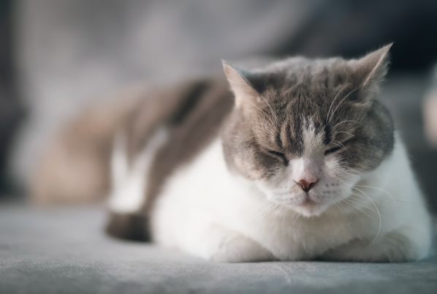
The loaf is another very popular position for cats to sleep in - sitting upright with her front paws tucked in under her body, making her look just like a loaf of bread.
It’s often accompanied by closed eyes, as a sign of complete contentment, but she’s unlikely to be in a deep sleep. This is far more of a quick catnap pose and chances are she’ll remain fairly alert. Regardless, this is a very relaxed cat sleeping position that lets her enjoy some rest while keeping watch over her kitty kingdom.

The Eyes Half Open
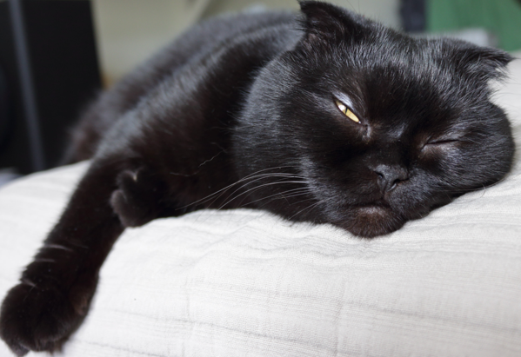
Cats sleep with her eyes half-closed and half-open half-closed when they may sense a threat – which can vary from imminent danger to a trivial annoyance. Or she may be watching out for something in the home - maybe there are unfamiliar people around or something has recently changed.
Another explanation for cats sleeping like this is because they have a third translucent eyelid between the other eyelids, protecting their eyes from irritants and dryness.
Rob Steele, from global pet company PetSafe® Brand, said: “One thing’s for certain, us Brits really do love our cats. They’re one of the nation’s most popular pets – second only to dogs - and almost a quarter of us (24%) will no doubt be celebrating International Cat Day, on Monday, in some way, with our favourite feline companions.

"We spend a lot of time watching them sleep, often wondering what they’re thinking and feeling. Are they dreaming? Are they cold and curled up for warmth? Are they happy and comfortable? Do they feel loved? That’s why we’ve shed some light on what their sleep positions mean, to give owners an even greater understanding of their beloved cats.”

Images are for online use only due to license. You can download images for each sleep position here https://we.tl/t-BCHdHRLU0E

petsafe.com/UK
ENDS

NOTES TO EDITORS
Contact:
For additional information, images and queries, contact Toast PR via Karen Winstanley - +44 7501 109296 / karen@toastpr.co.uk or via Rob Steele, PetSafe® Brand (Radio Systems) rsteele@petsafe.net +44 (0) 7850 206534.

About PetSafe® Brand
PetSafe® Brand is a global pet product expert renowned for developing high quality, reliable product solutions that strengthen the bond between pets and pet parents.

Following its launch in 1998, the PetSafe® brand was quickly and solidly built around the provision of trusted training solutions, with innovative ideas in Containment, Training and Bark Control. Whilst these popular categories remain today, other product solutions include Pet Doors, Harnesses and Walking Solutions, Pet Fountains & Feeders, Cat & Dog Toys, Waste Management and a Travel, Access & Mobility range.

Its in-house teams of engineers and innovative design specialists are constantly researching, testing and developing new products, working closely with pet behaviourists, veterinary professionals and every day pet parents to ensure products are effective at keeping pets healthy, safe and happy.

Visit www.petsafe.com/UK for further details or connect on Facebook, Twitter or Instagram.

