21 November 2022, UK

12 of the best Black Friday deals from PetSafe®
– all with savings of up to 30% off RRP

Pet-loving bargain hunters, listen up. Black Friday on its way to global pet brand PetSafe® – and there are some seriously brilliant buys and great Christmas gifting ideas to bag from Monday 21st November.

Here are 12 of the biggest bargains to add to your basket, as carefully compiled by PetSafe®’s expert team.

Top 7 Black Friday buys for dogs
Smart Feed Automatic Pet Feeder - RRP £174.99 Black Friday price £122.49 – saving 30%
Designed by pet parents to bring peace of mind to ‘doggy dining’, this nifty piece of tech can schedule, monitor and adjust your pooch’s feeding schedule remotely with the user-friendly, free-to-download smartphone app.

Simply connect the feeder to your home’s Wi-Fi and enjoy convenient meal scheduling and smartphone alerts that update owners when he’s been fed, when the food level is low, or if the feeder is empty.

For extra peace of mind, it also feeds on schedule as programmed even if the Wi-Fi connection is lost, or the feeder is offline.

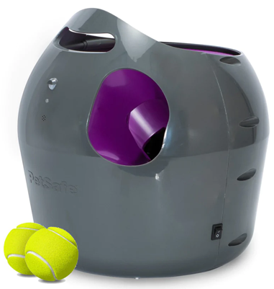
PetSafe® Automatic Ball Launcher - RRP £152.99, Black Friday price £130.04 – saving 15%
This a perfect choice of present for dogs who love balls, playing fetch and interactive play – and can be used both indoors and out, making it a brilliant energy-burning gift in winter, when the weather sometimes isn’t great.

With nine distance and six angle settings, this launcher holds up to three tennis balls at a time and shoots them between 2.5 to 9 metres – but only after a tone is played. Its careful design includes built-in motion sensors to safely detect people and pets nearby, and its automatic rest mode ensures our excited dog doesn’t overdo it.

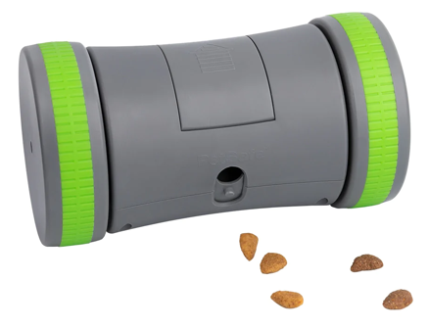
Kibble Chase™ Roaming Treat Dispenser - RRP £32.99 Black Friday price £26.39 – saving 20%
Playtime will become even more enjoyable when chasing treats dispensed from this interactive toy. Just load it with kibble, switch it on and let the fun begin.

The battery-powered interactive toy rolls randomly around the floor to keep your dog entertained - whilst releasing his favourite treats and encouraging lots of active play. It’s also a perfect treat puzzle present for dogs that eat too fast and even comes with a slow feed option, to further control how quickly food is dispensed.

And to make sure our dearest dogs don’t overdo it; this toy’s sleep mode ensures they get a break after 10 minutes, until its nudged again when he’s next ready to play.

Busy Buddy® Bouncy Bone™- RRP £6.99 to £22.99 (depending on size) Black Friday price £4.89 to £16.09 – saving 30%
This interactive Bouncy Bone™ toy will keep dogs entertained for hours. Its clever design – combining two of a dog’s favourite things, a durable nylon bone and rubber ball – makes for a most enjoyable and lengthy chewing experience. And this is made even more irresistible with its accompanying natural rawhide rings, which are easily loaded onto the toy by unscrewing the nylon bones. They provide a much more robust, long-lasting taste experience than standalone treats. The toy comes with four treat rings, with replacement treat rings also readily available.

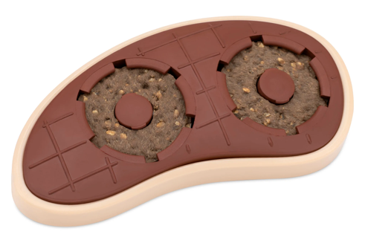
Slab o’ Sirloin Treat Ring Dog Toy – RRP from £9.99 to £13.99 Black Friday price £6.99 - £9.79 – saving 30%
This brilliant beef-scented, boredom busting toy makes for super-versatile interactive play and can be enjoyed in a variety of ways.

It holds up to two treat rings in its refillable treat-holding cups and, for double fun and extra entertainment, smear peanut butter or cream cheese in the grooves on the back.

As well as looking - and tasting! - like a delicious snack, it’s also a clever toothbrush. Its textured surface helps keep your dog’s teeth and gums clean by preventing and removing build-up as they chew and, for extra doggy dental hygiene, you can smear canine toothpaste in the grooves.

It comes in a choice of sizes, depending on the size of your dog. Four treat rings are included, and refills are available to buy separately.

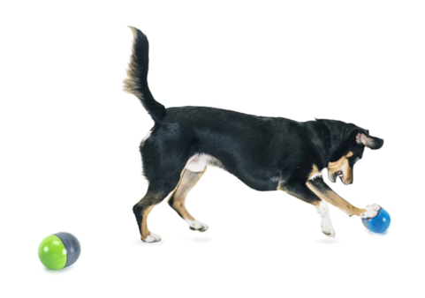
Ricochet Electronic Dog Toys - RRP £35.99 Black Friday price £25.19 – saving 30%
Dogs need mental stimulation and physical exercise to thrive, and this challenging toy achieves this - and then some. It’s sure to stimulate his brain and satisfy his natural canine behaviours, which makes it a perfect addition to your dog’s toy box.

The perfect gift choice for sound-motivated dogs, it comprises two robust Bluetooth paired toys with “moving” squeak noises that will have your dog bouncing back and forth as he tries to catch them. When your dog interacts with one of the toys, a fun and exciting squeak sound is heard from the other toy which, when investigated, bounces back to the first. Your dog will love trying to find the squeaky sound for hours. The play area and exercise can also be extended, as the toys can be positioned up to nine metres apart. Make the game more challenging by hiding one of the toys behind furniture or in a nearby room.

When your pooch is pooped, the toys will automatically turn off after 60 minutes to save its replaceable battery life.

Busy Buddy® Rawhide Treat Ring Refills (Size B) - RRP £9.99 Black Friday price £6.99 – saving 30%
These natural rawhide treat rings fit on the ends of select Busy Buddy® treat-holding toys. Refill your dog's toy for more chewing, more playtime and more fun.

They provide a much more robust, long-lasting taste experience than standalone treats. Size B fits select small and medium sized Busy Buddy® toys.

Top five Black Friday buys for cats
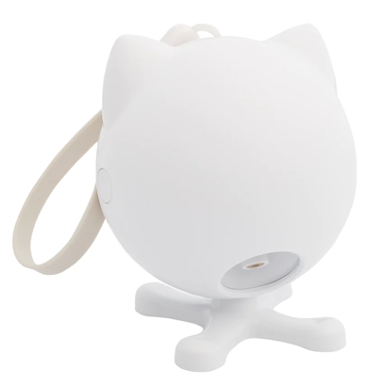
Dancing Dot™ Laser Cat Toy - RRP £25.99, Black Friday price £18.19 – saving 30%
Gift your cat the chance to pounce and play all day with this Dancing Dot™ Laser Cat Toy.

For hours of heightened feline fun – quite literally - position the toy on any elevated, flat surface, or hang it on a doorknob or handle, for wider and faster laser movement. This will keep her occupied, active and stimulated for even longer, which will do wonders for her health.

The clever design of the Dancing Dot™ Laser Cat Toy includes two play mode options and a random, moving laser display. Depending on the setting you choose, your cat can play for just 15 minutes or for regular 15-minute intervals every two hours – making it an ideal boredom buster when leaving her home alone.

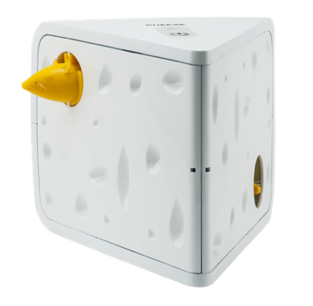
CHEESE™ Automatic Cat Teaser - RRP £25.99 Black Friday price £18.19 – saving 30%
If you think your cat would love to receive an exciting game of peek-a-boo this Christmas, then look no further than the Cheese™ Automatic Cat Teaser. What cat wouldn’t love to hunt two cheeky mice popping out of the sides of a block of swiss cheese?

This toy’s clever ‘Play While You Are Away’ mode will provide lots of spontaneous playtime throughout the day, making it an ideal gift choice for house cats and those who spend time home alone. It also features an automatic timer for single play sessions – switching off after 10 to 15 minutes, so that your feline doesn’t feel too fatigued.
Fox Den Toy Automatic Cat Teaser - RRP £28.99 Black Friday price £24.64 – saving 15%
The Fox Den is a motion activated toy that’s perfect for all day interactive feline fun. By engaging cats in peek-a-boo style play as the unpredictable fox tail appears at random intervals - keeping your cat totally captivated and encouraging her to bat and pounce. This stimulates your feline’s natural hunting instincts, which promotes healthy development in a way both you and your cat will love.

The toy’s ‘Play-All-Day’ mode makes it the perfect present for house cat ‘pawrents’ to gift, because it’s sure to keep them engaged for hours on end – even when they’re home alone.

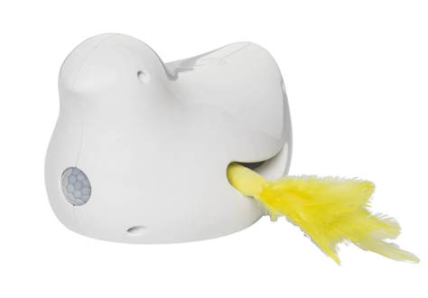
Peek-a-Bird™ Electronic Cat Toy - RRP £30.99 Black Friday price £21.69 – saving 30%
Your cat will go wild for the fluttering feathers of this popular choice of pressie from PetSafe®. The fun feather teasers of the electronic Peek-a-Bird™ toy flutters in and out of two different openings. This motion creates a fun target for her to chase and provides hours of enticing playtime - keeping your furry feline friend entertained all day long.

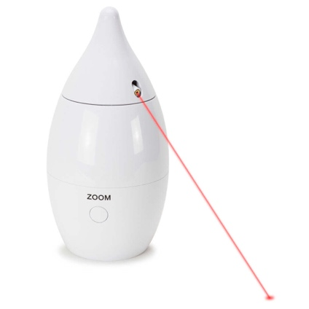
Zoom Laser Toy- RRP £26.99 Black Friday price £18.89 – saving 30%
With its two boredom-busting interactive red rotating laser light beams – that spin around in a 360-degree rotation - cats are kept guessing and entertained for hours.

Its double lasers make it a perfect gift for multi-cat households and, with its whisper quiet operation – and minimal electronic sounds – even the most timid of cats can enjoy it, without any noisy distraction.

PetSafe® brand’s Rob Steele said: “Black Friday has become one of the single most important dates in the calendar for anyone looking to snap up a bargain or two. This year we’ve compiled a roundup of brilliant buys – with great discounts - that our pets, and purses, are sure to love.”

View everything PetSafe® has to offer by visiting its website, or following on Instagram, Twitter and Facebook.
You can find a selection of images to accompany this release here XX
-ENDS-
NOTES TO EDITORS
Contact:
For additional information, images and queries, contact Toast PR via Karen Winstanley - +44 (0) 7501 109296 / karen@toastpr.co.uk or via Rob Steele, PetSafe® brand (Radio Systems) rsteele@petsafe.net +44 (0) 7850 206534.

About PetSafe® brand
PetSafe® brand is a global pet product expert renowned for developing high quality, reliable product solutions that strengthen the bond between pets and pet parents.

Following its launch in 1998, the PetSafe® brand was quickly and solidly built around the provision of trusted training solutions, with innovative ideas in Containment, Training and Bark Control. Whilst these popular categories remain today, other product solutions include Pet Doors, Harnesses and Walking Solutions, Pet Fountains & Feeders, Cat & Dog Toys, Waste Management and a Travel, Access & Mobility range.

Its in-house teams of engineers and innovative design specialists are constantly researching, testing and developing new products, working closely with pet behaviourists, veterinary professionals and every day pet parents to ensure products are effective at keeping pets healthy, safe and happy.

Visit www.petsafe.com/UK for further details or connect on Facebook, Twitter or Instagram.

