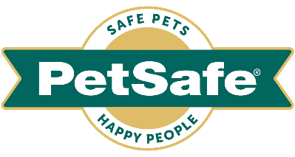
Media information

June 2023 – final draft

Four ‘pawfect’ products to keep cats and dogs healthy and happy when it’s hot

As temperatures remain high – and with forecasts for another record-breaking summer ahead of us – the nation’s pet parents are doing everything they can to ensure their cats and dogs stay hydrated, cool and comfortable in the heat.

When it’s hot outside they don’t drink enough water, cats and dogs can easily become dehydrated and can suffer from potentially fatal heatstroke, along with other illnesses.

So, whether you’re a new pet parent or seasoned pro, global pet brand PetSafe® has compiled this four-strong round-up of best-sellers, which will help keep our beloved dogs and cats healthy, happy and hydrated in the heat.

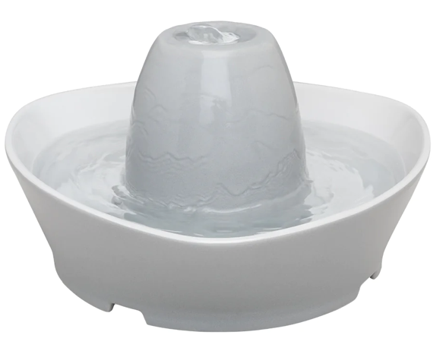
PetSafe® Streamside Ceramic Pet Fountain, RRP £70.99
The PetSafe® Streamside Ceramic Pet Fountain provides pets with a continuous fresh, filtered stream of water - naturally attracting cats and dogs and encouraging them to drink more. This popular model holds 1.8 litres of water – making it the perfect size for a cat or small dog.
Its whisper-quiet design sees water softly bubble over the hygienic ceramic tower - as opposed to a free-falling stream - which makes it perfect for more shy or timid pets. And its pump and carbon and foam filters remove pet hair, saliva and bad tastes from the water, so there’s always refreshingly clean water to drink.
Manufactured from premium materials, it’s hygienic, scratch resistant, and free of heavy metals. Even better, for ultimate ease and convenience, the ceramic tower and base can go in the dishwasher and it comes with a two-year warranty.

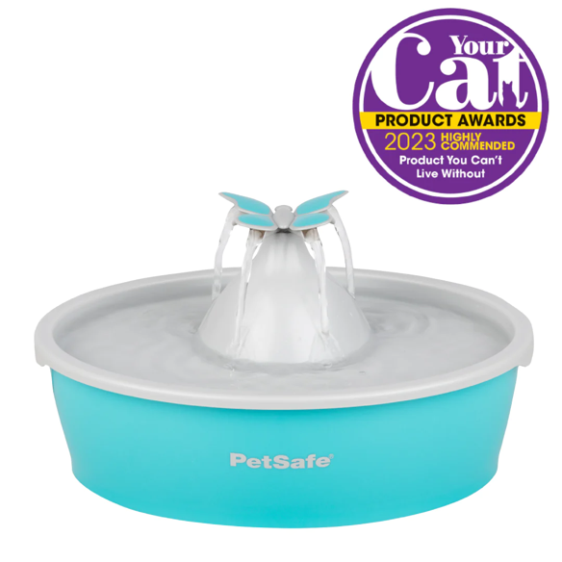
Drinkwell® Butterfly Pet Fountain, RRP £28.99
The PetSafe® Drinkwell® Butterfly Pet Fountain provides your pet with a constant stream of water, which again naturally attracts dogs and cats - encouraging them to drink and stay hydrated.
Its removeable butterfly topper adds a fun decorative element whilst creating four freefalling water streams to drink from. Or, create a quiet, bubbling water flow by simply removing the butterfly topper. The cleverly designed combination of carbon and foam filters remove pet hair, debris and bad tastes. It’s made from BPA-free plastic, with no hard-to-reach places to clean.

Frosty Cone Freezer Toy, RRP £5.99 to £12.99 depending on size
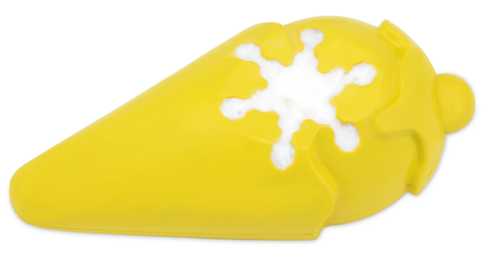
Help your pooch cool down and stay entertained this summer with this ice cream cone shaped freezer toy. It’s great for reducing boredom and anxiety as temperatures rise by keeping your dog busy and engaged. Fill it with water or dog-safe foods - like peanut butter, meat, soft cheese and veggies, or even his wet food - for a slow feed option to be savoured when it’s sunny outside. Even better, its grooves and crevices will help clean your dogs’ teeth and gums. The BPA-free rubber is vanilla scented to keep your dog happy even after the snack is gone. For ultimate ease and convenience, it’s dishwasher safe and it comes in two sizes – size small for dogs weighing 3.6 kg – 14 kg (£5.99 RRP) and size medium / large size for dogs weighing 14 kg – 36kg (£12.99).

Chilly Penguin, RRP £5.99 to £12.99 depending on size
Another favourite and best-selling treat holding freezer toy from PetSafe®, the design of the Chilly Penguin features a bowl-shaped cavity for ice and treats and its rounded base lets the toy wobble as dogs play and lick. For even more fun and hydration, penguins can be stacked in the freezer for easy storage and space-saving.

PetSafe® Brand’s Rob Steele said: “Water is essential to a pet’s overall health – especially so when it’s warm outside. It helps to regulate their body temperature, aids digestion and keeps their kidneys functioning properly. So, it’s very important to keep water bowls filled throughout the day and to ensure they have access to clean, fresh water at all times. This round-up of products provide some great ways to encourage greater consumption of water, which helps reduce the risk of heatstroke during summer.

“As a rule of thumb, dogs need 70 ml of water each day for every 1 kg of weight and, like humans, they should drink more when it’s hot. An adult cat needs between 50 ml and 70 ml fluid per kg of body weight daily so, if your cat weighs 4 kg, then she should drink at least 200 ml to 280 ml.”

For further information visit uk.petsafe.net

ENDS

NOTES TO EDITORS
Contact:
For additional information, images and queries, contact Toast PR via Karen Winstanley - +44 (0) 7501 109296 / karen@toastpr.co.uk or via Rob Steele, PetSafe® Brand (Radio Systems) rsteele@petsafe.net +44 (0) 7850 206534.

About PetSafe® Brand
PetSafe® Brand is a global pet product expert renowned for developing high quality, reliable product solutions that strengthen the bond between pets and pet parents.

Following its launch in 1998, the PetSafe® brand was quickly and solidly built around the provision of trusted training solutions, with innovative ideas in Containment, Training and Bark Control. Whilst these popular categories remain today, other product solutions include Pet Doors, Harnesses and Walking Solutions, Pet Fountains & Feeders, Cat & Dog Toys, Waste Management and a Travel, Access & Mobility range.

Its in-house teams of engineers and innovative design specialists are constantly researching, testing and developing new products, working closely with pet behaviourists, veterinary professionals and every day pet parents to ensure products are effective at keeping pets healthy, safe and happy.

Visit uk.petsafe.net for further details or connect on Facebook, Twitter or Instagram.

