November 2019, Canada
PetSafe® Brand Canada Launches
The Smart Feed Automatic Pet Feeder
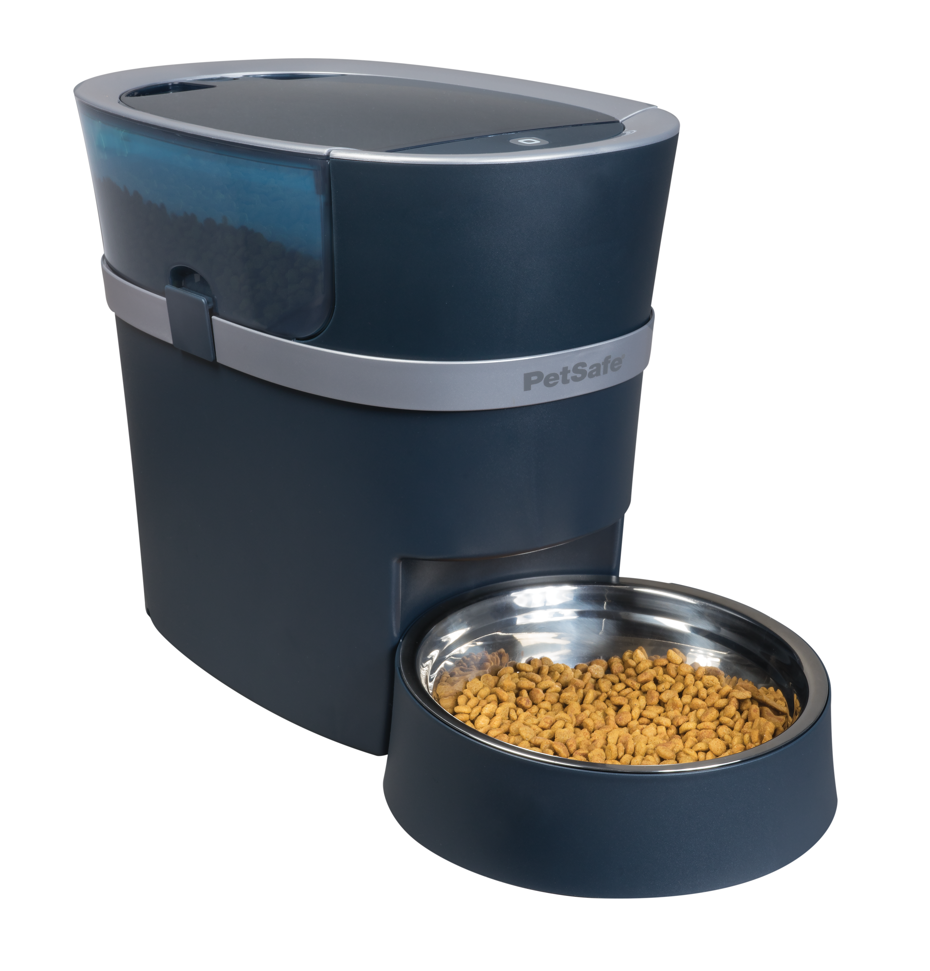
Feed your pet on time, every time!

In a conscious effort for continuous innovation, PetSafe® brand has launched the new Smart Feed Automatic Pet Feeder. Combining smart technology with the needs of pet owners, this new pet feeder can be programmed to sync with smartphones and dispense food at the touch of a button.

The PetSafe® Smart Feed Automatic Pet Feeder connects to Wi-Fi and allows pet parents to program and monitor their pet’s meals from anywhere, directly from the user-friendly free Smart Feed app on their smartphone (available in English and French). The feeder sends smartphone alerts when their pet is fed, and when it is low on food or empty, bringing peace of mind to meal time.

The feeder also allows pet owners to schedule up to 12 meal times a day, with portions from 1/8th of a cup to 4 cups. In addition to scheduled meals, the ‘Feed Now’ button can be used to dispense a snack or extra meal.

Other features include the ‘Slow Feed’ option for pets that gulp or eat too fast, a pet-proof dispenser to keep your pets from accessing the food, batteries to take over should the Wi-Fi drop at any point, and dishwasher safe parts to keep everything safe and hygenic.

MSRP (Suggested Retail Price): $269.99
petsafe.com/ca
ENDS

NOTES TO EDITORS
Contact:
For additional information on PetSafe® products, please contact canadasales@petsafe.net

About PetSafe® Brand
PetSafe® Brand is a global pet product expert with wide-ranging innovative products including training, containment, lifestyle and wellbeing product solutions. Visit www.petsafe.com/ca for further details or connect on Facebook or Instagram.

